National Safer Sleep Week 13- 19 March 2023
Resources for professionals
Description | Link to resource / attachment
NW region SIDS and Safer Sleep Training plus 3 45-minute live online interactive session with the Lullaby Trust, which gives participants the opportunity to discuss the recorded training material and to ask the trainer(s) practice related questions.
Sessions are between 12:00 – 12:45pm on:
• 14/03/2023 - NW region SIDS and Safer Sleep | NHS England Events
• 29/03/2023 - NW region SIDS and Safer Sleep | NHS England Events
• 25/04/2023 - NW region SIDS and Safer Sleep | NHS England Events

North West region Safer Sleep Task & Finish group – 7 Minute Briefing March 2023

Lullaby Trust infographic – statistics
Lullaby Trust -Safer Sleep in Winter
Lullaby Trust -Easy read card
Lullaby Trust -Fact sheet - Temperature
Lullaby Trust -Safer sleep advice for emergency situations
A guide for parents and carers
Lullaby Trust -Top 10 tips for health professionals working with young parents
Lullaby Trust -Reducing Sudden Infant Deaths in North West England
Lullaby Trust- a guide to buying safer sleep essentials
QR code for the Lullaby Trust – Professionals section | 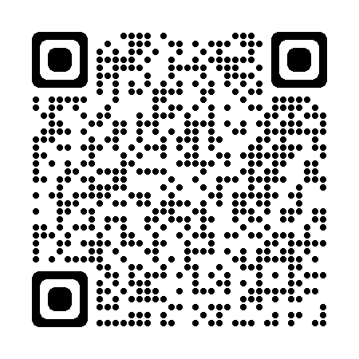
Institute of Health Visiting Excellence in Practice
RCGP Digital Poster
Out of routine: A review of sudden unexpected death in infancy ( SUDI ) in families where the children are considered at risk of significant harm
Been out for a drink – who’s in charge
Staying in to drink- who’s in charge
“Lift the baby” - Rugby Dads video, made in partnership between the NHS and London Irish Rugby Club | https://youtu.be/vtdLc6MtOxo  (skip ad to start film)
“Let’s talk about safer sleep and cold homes” – slide deck from event on 4 October 2022
Summary of feedback from delegates at Cold Homes and Safer Sleep event 4 Oct 2022 – Menti evaluation

