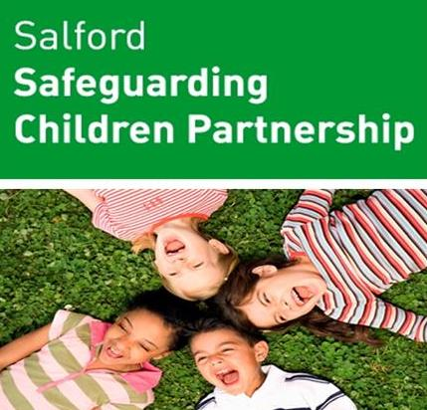

Reducing Parental Conflict in the Interest of Improved Outcomes for Children
Virtual Course
Overview
This training is an opportunity for all agencies with little to no training in reducing parental conflict to find out more about this important area of work.
The course is open to anyone who is in a position through a conversation or contact with a family to find out if parental conflict is an issue. Often where other factors are present, such as financial and housing worries, parents may also be struggling with their relationship. Research shows that understanding this and catching it early can make a real difference to a child.
For those of you who work directly with families the course will show you tools and approaches you can use with the family. For those of you who may identify a need and then refer on, the course will cover this, so you know where to go help.
The training will be delivered in 2 parts and delegates are encouraged to attend both sessions.
Session 1 will cover the difference between domestic abuse and parental conflict and session 2 will show you the Greater Manchester Relationships Tool Kit.
Group A
Session 1 | Time | Session 2 | Time
Thursday 21st April 2022 | 9.30am – 1pm | Thursday 28th April 2022 | 9.30am – 1pm
Group B
Session 1 | Time | Session 2 | Time
Thursday 12th May 2022 | 9.30am – 1pm | Thursday 19th May 2022 | 9.30am – 1pm

Group C
Session 1 | Time | Session 2 | Time
Wednesday 15th June 2022 | 9.30am – 1pm | Thursday 23rd June 2022 | 9.30am – 1pm

Group D
Session 1 | Time | Session 2 | Time
Tuesday 21st June 2022 | 9.30am – 1pm | Tuesday 28th June 2022 | 9.30am – 1pm

Group E
Session 1 | Time | Session 2 | Time
Thursday 7th July 2022 | 9.30am – 1pm | Thursday 14th July 2022 | 9.30am – 1pm

Places are on a first come first served basis. To request a place please email Debbie.hulme@salford.gov.uk with the following information:

- Preferred Group
- Name of delegate
- Job title
- Agency
- Team based with
- Full address where based with contact telephone number
- Email address
- Name of manager

The training will be delivered via Microsoft Teams and you will receive a calendar invite, followed by a link to the course.

