|  |  |  |  |
| --- | --- | --- | --- |
| Salford Safeguarding Children Partnership |  |  | C:\Users\Carole Brooks\AppData\Local\Microsoft\Windows\INetCache\IE\L4ZLZ0JA\web-1873373_960_720[1].png Click here to access the [SSCP website](https://safeguardingchildren.salford.gov.uk/)  for information about us |

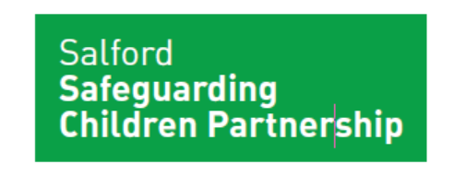

### Helping us to understand and shape how we can reduce the prevalence and impact of neglect on the lives of children in Salford.

Neglect is one of the most common forms of childhood maltreatment and remains local area priority. This Neglect Seminar brings together Salford professionals to share the findings of the most recent multi-agency neglect audit and to highlight key areas for consideration.

Presentations will be delivered on the following subject areas:

* Salford neglect audit findings and outcomes
* Support and Safeguarding Guidance 2022
* Early help and The Thriving Families Assessment Tool.
* The impact of poverty in understanding neglect

## Monday 28th March 2022

**2pm to 4.15pm On-Line**

**Venue: xxxx**

**NEGLECT VIRTUAL**

**SEMINAR**

**How to book your place**:

The link to the booking form can be accessed [here](https://forms.office.com/Pages/ResponsePage.aspx?id=YADAaA7YpUC4PzuKW8VwtQxDiDgI1RFIrHvmKCOCIZ9UM1VTQU5EOVZTVTFNTkY5Nkg5WEdSM0JOWC4u).

Please note the closing date for bookings is Friday 18th March 2022.

You will receive a link to the online session approximately 1 week before the seminar.

## Who should attend?

A wide range of strategic leaders, professionals and communities who work with, or commission services for children and their families in Salford. For example, early help, education, health, housing, social care, voluntary sector, welfare, youth services, amongst many others.