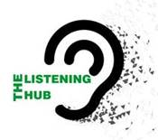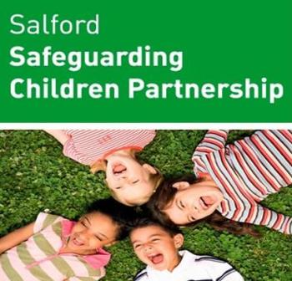

Salford Safeguarding Children Partnership

**EMOTIONAL HEALTH & WELLBEING EVENT**

Ensuring the “voice” of children, young people, parents/carers, and residents from the local community helps drive the work of the SSCP.

For more information visit:

[Listeninghub | Salford Safeguarding Children Partnership](https://safeguardingchildren.salford.gov.uk/children-and-young-people/listeninghub/)

Safeguarding is everybody’s responsibility and we all need to work together to

The purpose and aim of this online Listening Hub event is to:

* Listen to the voices/lived experiences of parents/carers/children/young people and professionals.
* To explore ways in which Emotional Health & Wellbeing can be managed
* To understand “what would make a difference”
* To improve our Service Delivery based on what you tell us
* Focus of the day will be on “Getting Help” – The “I-Thrive model” (where & how) – self-care & sign posting
* The NHS 5 ways to wellbeing

The day will use creative exercises and be fun!

|  |  |  |
| --- | --- | --- |
| **Date** | **Time** | **Closing Date for bookings** |
| Monday 7th March 2022 | 10.30am – 3.00 pm | Friday 21st February 2022 |

To book a place please contact [debbie.hulme@salford.gov.uk](mailto:debbie.hulme@salford.gov.uk)

When booking please ensure you provide all the following information:

* Name of delegate
* Job title
* Agency
* Team based with
* Full address where based
* Email address

You will receive joining instructions following the closing date for bookings. If you require any further information, please contact Maria Ogunyemi (Participation/Listening Hub Lead SSCP) on: [Thelisteninghub@salford.gov.uk](mailto:Thelisteninghub@salford.gov.uk)

**LOOKING FORWARD TO MEETING YOU AND HEARING YOUR VIEWS!**

