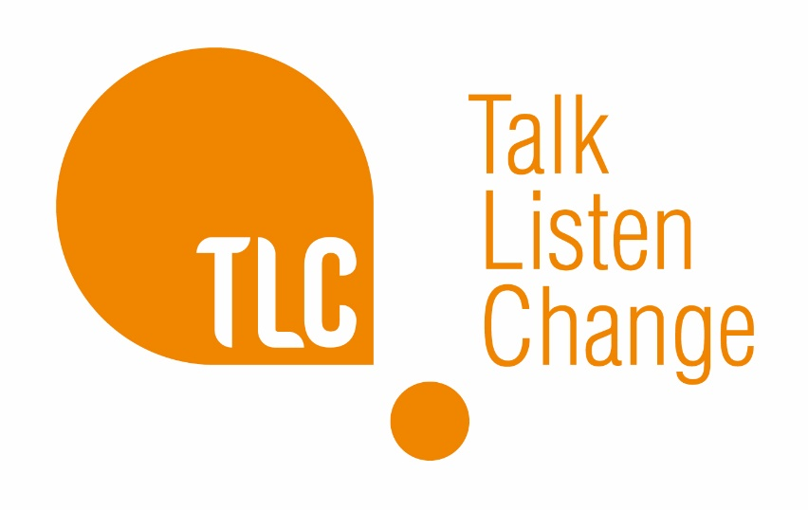
Striving for Change

Motivation and Awareness

Overview:

Strive Eligibility Criteria

- Standard risk DA incident: assessed using Safe Lives DASH RIC form and checked again based on central data held within local authority case management systems as detailed below)
- Client motivation: Client would like support with their relationship and is willing to attend a programme of work on a voluntary basis
- Not currently involved in care proceedings

Additional TLC Considerations:

- Aged 21+: Consideration will be given to clients between the ages of 18-21 as part of a dual assessment. Dual assessment includes all of the below considerations in additional to assessing clients mental and emotional ability to ascertain if client can safely participate in an intervention which may mean attending long term behaviour change work in a group setting.
- Ability to complete group work if recommended without an interpreter.

Service Specification:

Service for those in an unhealthy or abusive relationship (which may not be apparent to them. The client may not recognise this as an unhealthy relationship but may feel something is wrong. This service allows the client to explore their own behaviours in a safe and non-judgemental environment.
- Striving for Change offers up to 6 sessions supporting clients to recognise their behaviour and motivate them to work towards further change if necessary.
- SESSION 1/2: Participation agreement, initial assessment interview, and completion of relevant paperwork
- SESSION 3: Identifying healthy, unhealthy and abusive relationships
- SESSION 4: Awareness of the impact of domestic abuse on children
- SESSION 5: Reflections on own incidents of abuse
- SESSION 6: Awareness of the impact of Domestic Abuse on self/partner/children and evaluation
- Referrals for longer term behaviour change work can be made if behaviours being displayed/discussed are of an abusive nature and additional work is needed.
- Low risk cases may only need this piece of work
- Medium-high risk cases may access this as a motivational tool to support them into longer term behaviour change work.

Striving for Change Integrated Partner Support
- Replication of the above support offered to the partner/ex-partner of referred ‘perpetrator’. Service is offered to:
- increase understanding of the support/challenge being offered to their partner/ex-partner,
- increase their own understanding of the abuse that they may have been/continue to be subjected to
- increase their understanding of the support available to them
- assess and monitor potential change in behaviours/attitudes of the abusive partner through the voice of the victim
Children and Young people’s Service
- Service offered to children and young people between the ages of 5-18yrs connected to parents who are accessing the above services.
- 6 sessions of 1-2-1 counselling support (more if needed), delivered in local community settings including schools. Needs led therapeutic support.
- Group work peer support activities. An opportunity for children to access high quality youth work sessions in a safe, non-judgemental space, with staff who are aware of the complexities of their home life.
- Children can access either 1-2-1 counselling support, group work activities or both during their engagement with TLC.

Critical Communication with professionals and clients:

It is critical that both referring agencies and clients are fully aware that TLC: Talk, Listen, Change are not endorsing the Striving for Change Motivation and Awareness Extended assessment as a behaviour change intervention. TLC are clear that Striving for Change is a precursor to attending and hopefully completing a full DVPP to enable sustainable change through a long term behaviour change intervention. All contracting arrangements for Striving for Change across each of the Greater Manchester regions have included referral pathways through to longer term behaviour change programmes for those that are willing and suitable to continue working towards sustainable change. This is particularly pertinent to cases that have been referred through Children’s Social Care and needs to be reflected in any and all correspondence/reports to allocated social workers, ensuring they are fully aware of the limited capability for change and risk reduction within this process, in isolation.

