# De-escalation plan

## Purpose

This plan is an aid to support you to management your behaviours more effectively.

Please state what behaviours you display when emotionally charged

CircleCircleCircleCircleCircleCircle

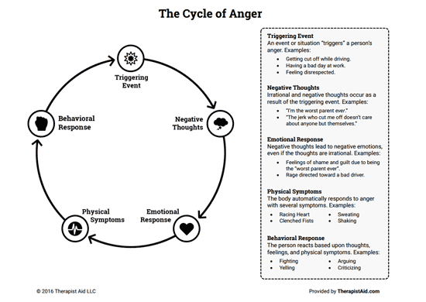

Reviewing the anger cycle with your most recent incident in mind please state a plan to manage your emotions more effectively.

I will;

1

2

3

4

5

I will not;

1

2

3

4

5

I am responsible for my behaviours and will take accountability for them

I will take a time out if I feel……………………………………….

I will contact for support………………………………………………………….

I will go to ……………………………………………………………

I will use this de-escalation plan to keep myself and my family safe and will not breach the working agreement I have signed and I am aware that if this occurs Salford City council may take action to protect the welfare of my child/ren

Signed………………………………….

Date……………………………………