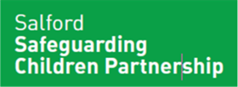
Salford Parent Panel

We are setting up a Salford Parent Panel and asking parents/guardians/carers to work with us in partnership to keep our Children and Young People Safe and Well and make sure they have what they need to be their best.
You are the experts every day in your children’s lives. We want to work with you to guide and grow the way we work in partnership with families.
Whatever your personal experience of caring for a child in Salford we value your views, we will not ask for details about your journey or experiences and we hope that parents with a wide range of understanding of children’s services will help us to develop new ways of working together.
“Safeguarding children is everyone’s responsibility and for services to be effective each citizen, practitioner and organisation should play their part. We are asking the community of Salford to play their part to help us understand the needs of Salford’s children and families and help us in preventing harm.” Salford Safeguarding Children Partnership 2019

We want to hear your views about how we can succeed together.
If you would like to be involved in the Salford Parent Panel to help us, please complete the consent form overleaf, which can be either emailed by yourself or the professional you are working with to: cpru@salford.gov.uk
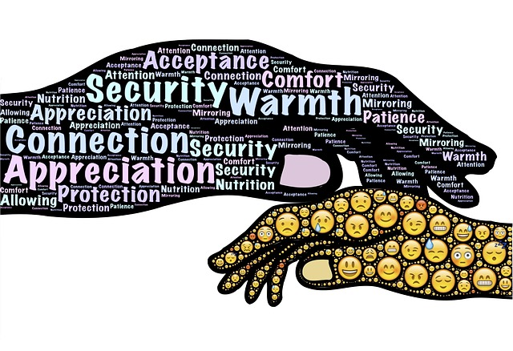

Working together to make a difference in Salford - Consent form
Consent Form:
I would like help Salford City Council and the Salford Safeguarding Children Partnership by being part of the Salford Parent Panel.

Name:

Address:

Telephone: Mobile Phone:

E-Mail:

Please indicate your current relationship with children: (please circle all that apply)

Parent Grandparent Guardian Carer

Preferred method of contact: (please circle all that apply)

Phone Mobile Phone E-Mail

I understand that I can contact cpru@salford.gov.uk to withdraw this consent at any time.

Your Signature:
Date

Staff/Professional Signature:
Date

For more information about how we use your data, please see our Privacy Notice on the council’s website at: https://www.salford.gov.uk/your-council/council-and-decision-making/data-protection-legislation/

