
PRACTICE REVIEW POLICY AND TOOLKIT
Lead Reviewer Specification

Purpose

The purpose of this document is to outline the desirable requirements and essential behaviours for lead reviewers of practice reviews. It is heavily based on the specification for National Panel reviewers.

Role Description
Reviewers will be appointed, commissioned, and supervised by the Salford Safeguarding Children Partnership (SSCP) and the Chair of the Practice Review sub-group. SSCP will stipulate the scope and parameters of each review, which will be proportionate to each incident or theme of investigation.

Reviewers will be expected to:

- Gather evidence and analyse the root causes of what happened and why in order to identify improvements which can be directly made by practitioners, organisations, and local and national Government.
- Work to agreed timescales and expectations with SSCP.
- Work closely with the SSCP Business Manager and Chair of Practice Review Sub Group, acting on their steers and feedback on drafts or plans of the review. SSCP may make written requests to a reviewer for information or a draft report during the review. The reviewer may also be asked to attend meetings with SSCP to discuss the progress of a review.
- Be proportionate in their investigation and analysis. Reviews should focus on identifying improvements rather than giving a detailed narrative of the incident.

Person Specification
Reviewers should provide evidence of the ability to:

- Keep the review focused on the lived experience of the child and family
- Involve safeguarding partners and practitioners in contributing their perspectives without fear of being blamed for actions they took in good faith.
- Recognise the complex circumstances in which practitioners work together to safeguard children.
- Understand practice from the viewpoint of the individuals and organisations involved at the time rather than using hindsight.
- Distil findings and analysis from a number of studies and cases in order to inform the report’s recommendations.
- Arrive at evidence-based recommendations which focus on professional learning and increasing expertise.
- Involve families, including surviving children, sensitively and transparently, so that they understand how they will be involved and have appropriate expectations. This is important for ensuring that the child is at the centre of the process.
- Work to an agreed schedule. In most cases this will be within a maximum of 6 months, with set dates for sharing drafts of the review with SSCP.
- Build relationships with interested parties quickly and instil their confidence.
- Deploy political intelligence, with an understanding of the critical levers for, and obstacles to, change.
- Handle information securely, being transparent about the way data is collected and analysed.
- Handle media attention sensitively and in consultation with SSCP, having an awareness of how information lands in the public domain.
SSCP will also consider a potential reviewer’s knowledge, understanding and practice relevant to the ability to undertake and write a national review. This may involve professional knowledge and practice specific to the case or cases under review.

For most cases a reviewer will be required to get to grips quickly with:

- The complex circumstances in which professionals work together to safeguard children, including the impact of management, supervision, resources, skills and training.
- The relevant national and local legislative and policy frameworks within which services operate.
- The local and national safeguarding system, including an understanding of the critical levers for change, the priorities at play, and how these interact across networks.
- The principles of the systems methodology recommended by the Munro review. The methodology employed by the reviewer should provide a way of looking at and analysing front line practice as well as organisational structures and learning. The methodology should be able to reach recommendations that will improve outcomes for children.
Potential Reviewers should be aware that SSCP may require additional skills and experience from those listed above, depending on the nature of the review.

Principles of conduct

Reviewers should be keenly aware of how their behaviours impact on the authority of the improvements that they state in their reviews. It is therefore imperative that reviewers are able to adhere to the following principles of conduct:

Child and family
Focused The outcome of all national reviews should ultimately be to improve the lives of children. Reviewers must therefore act solely in the interests of improving the welfare and protection of children.

Integrity Reviewers should be free from any obligation which could, or which could be seen to, compromise their freedom to identify improvements that should be made by sector, government or others.

Objectivity Reviewers should base their recommendations on the evidence in front of them, and should conduct their investigation without prejudice or assumption. This includes respecting operational delivery methodology (e.g. Signs of Safety) without prejudice.

Confidentiality In carrying out their investigations, reviewers must at all times adhere to laws and guidance regarding the handling of personal information.

Appendix A: Excerpt from Working Together to Safeguarding Children 2018

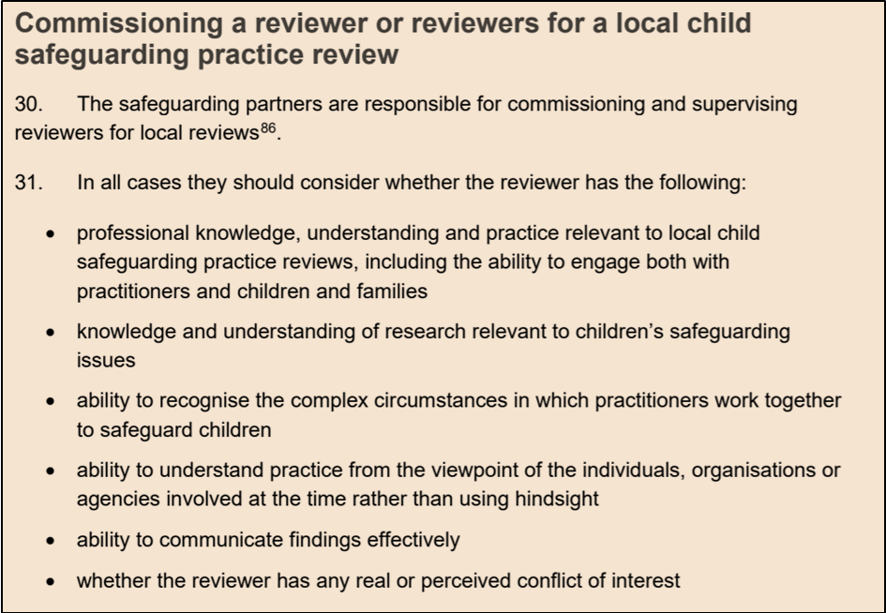

A Study of Family Involvement in Case Reviews: Messages for Policy and Practice, BASPCAN, Morris, K., Brandon, M. and Tudor, P.(2012)
The Munro Review of Child Protection: Final Report: A Child Centred System (May 2011).

