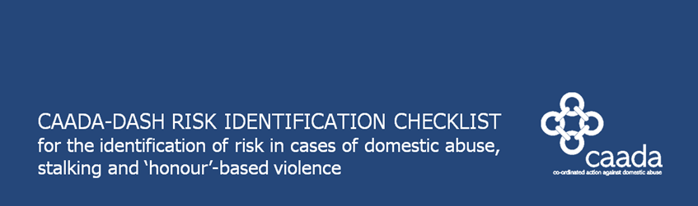

YOUNG PEOPLE’S VERSION

**RESTRICTED WHEN COMPLETED**







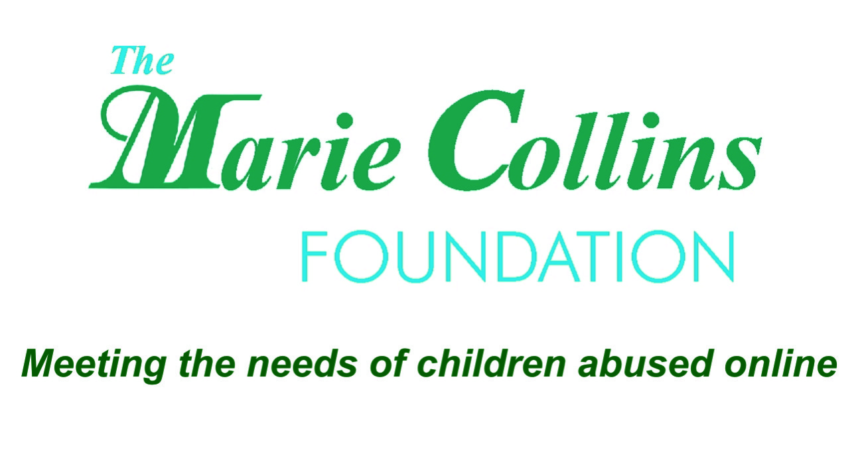

In partnership



**Salford Young Persons Domestic Abuse meeting**

|  |
| --- |
| * *Referrals need be uploaded to the relevant SharePoint site.* * *Boxes marked with * must be completed. If the requisite information is not given, the referral will be withdrawn and the referring agency requested to re-load a completed form.* * *Referrals will only be accepted in Microsoft Word format.* * *Referral documents must be named as the name of the victim and date of referral as shown below:* * *SURNAME [surname in upper case] Forename [First letter upper case, remainder in lower case] Date of referral in a number format e.g.* **BISHOP Amanda 01022013** * *If the question is not applicable or the victim is unable to respond, please indicate this on the form.* |

|  |  |  |  |  |  |
| --- | --- | --- | --- | --- | --- |
| Date of referral* |  | | | | |
| Referring agency* |  | | | | |
| Contact name(s)* |  | | | | |
| Telephone / Email* |  | | | | |
| Date of most recent DV incident* |  | | | | |
| **The Victim:** | | | | | |
| Victim name* |  | | DOB* | |  |
| Other names |  | | School / College / Place of work | |  |
| Address* |  | | Diversity Data (if known)  B&ME  Disabled  LGBT  Gender M / F | | |
| If the above address is temporary, please give details of the victim’s last permanent address | |  | | | |
| Telephone number* | |  | Is this number safe to call?* | Yes/No (*delete as appropriate*) | |
| Please insert any relevant contact information e.g. times to call | |  | | | |
| GP Details (if known) | |  | | | |
| **The Person who harms:** | | | | | |
| Person who harms name* |  | | DOB* | |  |
| Address* |  | | Relationship to victim* | |  |
| School / College / Place of work |  | | Telephone Number | |  |

|  |  |  |  |  |  |  |
| --- | --- | --- | --- | --- | --- | --- |
| **Victim’s Persons with Parental Responsibility:** | | | | | | |
| Name | DOB* | Sex* | Relationship to victim* | Relationship to person who harms* | Address * | Contact Details |
|  |  |  |  |  |  |  |
|  |  |  |  |  |  |  |
|  |  |  |  |  |  |  |

|  |  |  |  |  |  |  |
| --- | --- | --- | --- | --- | --- | --- |
| **The Person who harms Persons with Parental Responsibility:** | | | | | | |
| Name | DOB* | Sex* | Relationship to person who harms* | Relationship to victim* | Address * | Contact Details |
|  |  |  |  |  |  |  |
|  |  |  |  |  |  |  |
|  |  |  |  |  |  |  |

|  |  |  |  |  |  |  |
| --- | --- | --- | --- | --- | --- | --- |
| **Other Children:** | | | | | | |
| Name | DOB* | Sex* | Relationship to person who harms* | Relationship to victim* | Address * | School |
|  |  |  |  |  |  |  |
|  |  |  |  |  |  |  |
|  |  |  |  |  |  |  |
|  |  |  |  |  |  |  |

|  |  |  |  |  |
| --- | --- | --- | --- | --- |
| **Reason for Referral / Additional Information – This section must be completed in full\*** | | | | |
| Visible high risk (*14 ticks or more on CAADA - DASH RIC*) | Yes/No (*delete as appropriate*)  Comments: | | | |
| Repeat (further incident identified within twelve months from the date of the last referral).  If this is a repeat referral, please provide the date it was last at the YPDA meeting | Yes/No (*delete as appropriate*)  Comments: | | | |
| Potential escalation – please explain | Yes/No (*delete as appropriate*)  Comments: | | | |
| Professional judgement  If the reason for the referral is Professional Judgement please explain fully why you feel the victim is at risk of murder or serious harm | Yes/No (*delete as appropriate*)  Comments: | | | |
| Is the victim aware of the referral? | Yes/No (*delete as appropriate*) | If no, why not?* |  | |
| Has consent to the YPDA referral been given? | Yes/No (*delete as appropriate*) | | | |
| Who is the victim afraid of? (to include all potential threats, and not just primary perpetrator) |  | | | |
| Vulnerability of the victim e.g. physical or learning disability, old age, mental or significant mental illness. |  | | | |
| Have there been any threats of arson? If so, please give details. |  | | | |
| Is there any other relevant information from victim or professional that may increase risk levels? |  | | | |
| Has the victim been referred to any domestic abuse meeting previously? | Yes/No (*delete as appropriate*) | If yes where / when? | |  |

YOUNG PEOPLE’S VERSION

CAADA-DASH RISK IDENTIFICATION CHECKLISTfor the identification of risk in cases of domestic abuse, stalking and ‘honour’-based violence



**This form is suitable for use with young people aged between 13 and 17.[1]**

This Young People’s Checklist is split into questions that require yes/no responses, and areas where you are required to make observations. Please use the comment boxes provided throughout the form to record your professional judgement about how the young person’s specific situation affects their risk.

At the end of the Checklist, consider the number of questions the young person has answered yes to and your professional judgement in combination, and offer risk management options based on this. You have a responsibility and a safeguarding duty to respond to young people at the earliest point possible to prevent exposure to and escalation of abuse. **It is assumed that your main source of information is the young person who has been harmed. If this is not the case please indicate in the right hand column.**

|  |  |  |  |  |
| --- | --- | --- | --- | --- |
|  |  |  |  | **State source of info** if not the young person who has been harmed (eg police officer) |
| **Your feelings** | **Yes** | **No** | **Don’t know** |
| 1. Are you frightened?   Comment: |  |  |  |  |
| 1. What are you afraid of? Is it further violence?   Comment: |  |  |  |  |
| 1. Are you feeling low or finding your emotions hard to cope with?   Are you having suicidal thoughts? |  |  |  |  |
| **Consideration as part of your professional judgement** | | | | |
| * Does the young person recognise what a dangerous situation might be and their own vulnerability? * Are they exploring risk-taking behaviour as part of their development? How might this affect their safety? * Would this young person involve the police if they were to be hurt again?   **Comment:** | | | | |

|  |  |  |  |  |
| --- | --- | --- | --- | --- |
| **What is happening to you now** | **Yes** | **No** | **Don’t know** | **Source** |
| 1. Has the current incident resulted in injury?   Please state what and whether this is the first injury: |  |  |  |  |
| 1. Does [INSERT NAME OF INDIVIDUAL WHO IS HARMING THE YOUNG PERSON] constantly text, contact, follow, stalk or harass you, either in person, online or by phone? |  |  |  |  |
| 1. Does […] try to control everything you do? (For example, who you see, or what you wear?)   Do they get jealous about anything you do? |  |  |  |  |
| 1. Is the abuse happening more often? |  |  |  |  |
| 1. Is the abuse getting worse? |  |  |  |  |
| **Consideration as part of your professional judgement** | | | | |
| * How old is the young person? Where are they within the formal education system? * Is there any evidence that the young person may be minimising or exaggerating their experience?   **Comment:** | | | | |
| **Your life and relationship** | **Yes** | **No** | **Don’t know** | **Source** |
| 1. Do you see your family/friends as much as you would like? Does […] stop you from seeing friends and family or professionals?   Comment: |  |  |  |  |
| 1. Are you pregnant or do you have a baby? |  |  |  |  |
| 1. Are there any financial issues?   For example, is […] experiencing difficulties with money (debts or loans) or are you dependent on […] for money or do they take money from you? |  |  |  |  |

|  |  |  |  |  |  |
| --- | --- | --- | --- | --- | --- |
| **Consideration as part of your professional judgement** | | | | | |
| * Is this the first relationship the young person has been in? How is this impacting on their friendship group/understanding of acceptable behaviour? * Has the young person experienced abuse and violence within their family and has this affected their understanding of effective conflict resolution or normalised the experience of violence? Does it also limit the safe places they can be? * Is the young person involved or affiliated to any gangs and does this mean that there are additional risks posed by other people? * Is the young person at risk of sexual exploitation? Specific risk factors may include being reported missing from care, being missing from home, being in the care of the local authority and living in a residential home. Are you or colleagues aware of specific risks within the community from known perpetrators? * Does the young person have any specific needs or vulnerabilities in relation to disability and learning difficulties, substance misuse, mental health issues, cultural/language barriers, ‘honour’-based systems or geographic isolation?   **Comment:** | | | | | |
| **Things that might have happened to you in the past** | | **Yes** | **No** | **Don’t know** | **Source** |
| 1. Have you broken up with or tried to break up with the person who is hurting you? | |  |  |  |  |
| 1. If you have children, is there conflict between you and the person who is hurting you over seeing the children? | |  |  |  |  |
| 1. Has […] ever used weapons or objects (such as a phone or household item) to hurt you? | |  |  |  |  |
| 1. Has […] ever threatened to kill you or someone else?   If yes, please specify:  You 🞎 Children 🞎 A member of your family 🞎  Other (please specify) 🞎 | |  |  |  |  |
| 1. Has […] ever attempted to strangle/choke/suffocate/drown you? | |  |  |  |  |
| 1. Does […] do or say things of a sexual nature that make you feel bad or that physically hurt you or someone else?   If someone else, specify who. | |  |  |  |  |
| 1. Is there any other person who has threatened you or who you are afraid of? | |  |  |  |  |
| 1. Do you know if […] has hurt anyone else?   If yes, please specify:  Children 🞎 Another family member 🞎  Someone from a previous relationship 🞎  Other (please specify) 🞎 | |  |  |  |  |
| 1. Has […] ever mistreated an animal or their family pet? | |  |  |  |  |
| **The person who harms you** | | **Yes** | **No** | **Don’t know** | **Source** |
| 1. Has […] had problems in the past year with drugs (prescription or other), alcohol or mental health, leading to problems in leading a normal life?   If yes, please specify which and give relevant details if known:  Drugs 🞎 Alcohol 🞎 Mental Health 🞎 | |  |  |  |  |
| 1. Has […] ever threatened or attempted suicide? | |  |  |  |  |
| 1. Has […] ever breached their bail conditions or not followed an order by the police or a judge in court?   Bail conditions 🞎 Child contact arrangements 🞎  Forced Marriage Protection Order 🞎 Other 🞎 | |  |  |  |  |
| 1. Do you know if […] has ever been in trouble with the police or has a criminal history?   If yes, please specify:  DV 🞎 Sexual violence 🞎 Other violence 🞎 Other 🞎 | |  |  |  |  |
| **Consideration as part of your professional judgement** | | | | | |
| * Is the person who hurts your client older than them? By how many years? * Is the person who hurts your client gang involved or affiliated? Does this place your client or additional potential victims (consider all family members) at additional risk?   **Comments:** | | | | | |
|  | **TOTAL ‘YES’ RESPONSES** |  |  | | |

|  |
| --- |
| **What additional concerns do you have, based on your professional judgement/escalation?** |
| **Comments:** |
| **Is the young person willing to engage with your service?** |
| **Describe:** |

|  |
| --- |
| **Consider the person causing harm’s occupation/interests** |
| * Could this give them unique access to weapons? * How involved is your client in relation to any illegal weapons and how might this affect their safety and help seeking?   **Describe:** |
| **What are the young person’s greatest priorities to address their safety?** |
| **Describe:** |

|  |
| --- |
| **The experience of relationship abuse by young people is a safeguarding issue which should be shared with your safeguarding children’s team. A referral will also be required if you believe that there are risks facing any children in the family.** |
| Please confirm if you have made a referral to safeguard the young person and any children they have:  Yes / No  Date referral made: .… /…. / ….  **Signed: Date:** |
| **If the young person is over 16, do you believe that there are reasonable grounds for referring this case to MARAC?** |
| Yes / No  If yes, have you made a referral?  Yes / No  **Signed: Date:** |

|  |  |
| --- | --- |
| **Signed:** | **Date:** |
| **Name:** |  |

1. The transitional stage of adolescence can vary between young people, therefore this form may be suitable for use with young people up to the age of 25.