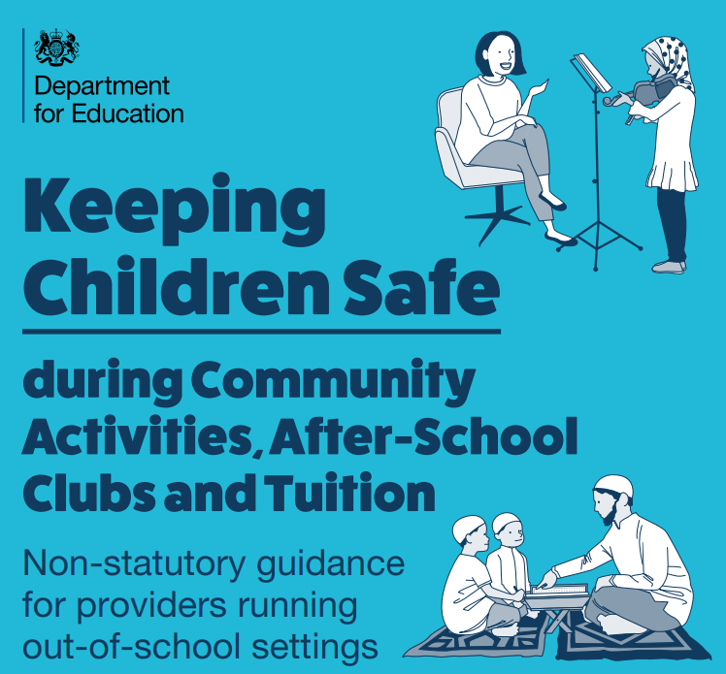
What are Out-of-School Settings (OOSS)?
Out Of School Settings are organisations or individuals that provide tuition, training, instruction, or activities to children in England without their parents’ or carers’ supervision, but are not:
- schools
- colleges
- education settings providing alternative provision
- 16-19 academies
- providers caring for children that are registered with Ofsted or a childminder agency
These settings generally provide tuition, training, instruction, or activities outside normal school hours (for example, evenings, weekends, school holidays), although some settings are run part-time during school hours to help meet the needs of those in home education.
These organisations include, but are not limited to,
- Community activities
- Before and after school clubs
- Holiday clubs
- Supplementary schools
- Private tuition
- Music lessons
- Sports training

Although this guidance After-school clubs, community activities, and tuition - safeguarding guidance for providers (publishing.service.gov.uk) is non-statutory, it is to be regarded as best-practice. The Department of Education is encouraging organisations, clubs, and tuition providers (out of school settings) to follow it.
OOSS should not be operating full-time (preventing a child attending a lawfully operating school); and would probably be regarded as operating illegally if it also met the remaining requirements for registration as an independent school. In such cases, the providers would risk a criminal prosecution for operating an unregistered school.

As a provider of an OOSS, you and your staff and volunteers have a duty of care toward the children who attend. This means that by law you must take reasonable steps to ensure the safety of the children and to protect them from harm.
As detailed in DfE statutory guidance Working together to safeguard children - GOV.UK (www.gov.uk) no single practitioner can have a full picture of a child’s needs and circumstances, so everyone who comes into contact with them has a role to play in identifying concerns, sharing information and taking prompt action.

It is recognised that characteristics of settings can vary, including the activities and learning they offer, so the steps you take to reduce the risk of harm to children in your setting will differ depending on its specific characteristics (for example, size, type of activity or tuition being offered, physical location, hours of operation). However, taking appropriate steps to reduce risk will reassure parents that their children will be safe in your care.

Changes from the Previous Guidance 'Keeping Children Safe in Out-of-School Settings'

The new guidance strengthens the older documents in a number of areas, particularly in governance, working with children who have SEN and disabilities, staff recruitment and management, the record-keeping of training, the steps to take when a child goes missing from the activity. The new document clarifies a number of areas, including that no external visitors should be observing the session unless they have identified themselves and signed in.
The guidance reminds organizations that in June 2022, the Sexual Offences Act 2003, was changed to include a broader range of roles in the 'position of trust' offence. In addition to teachers, these rules now prevent adults from engaging in sexual activity with a person who is 16 or 17 years old who they are coaching, teaching, training, supervising, or instructing in a sport or religion.

How this Guidance can help you as a provider.

The guidance will help providers understand how they can run safe settings to ensure the welfare of the children attending them. Following the guidance is not mandatory (except for the existing legal requirements specified).
However, all the actions outlined are good practice and should be supported by effective leadership and training. We strongly encourage you to put in place robust policies that will help you meet your duty of care towards all children attending your setting and to review them regularly to ensure the children in your care are kept safe from all forms of harm.

The guidance covers safeguarding best practice in 4 sections:

- Safeguarding and child protection.
- Suitability of staff and volunteers.
- Health and Safety
- Governance

Working with Schools

To ensure that nothing falls through the gaps, the out-of-school settings guidance says:
'If you use a school, college, or local authority premises, they... must continue to have regard to .. Keeping children safe in education 2023 when using school premises you should continue to implement this guidance for example, appointing your own DSL and putting in place safeguarding policies and procedures specific to your activity. However, you must also comply with any terms that the school, college or local authority sets.
Check that the school or college has included safeguarding in their rental or hire agreement; or memorandum of understanding if there is no formal contract.' (See 'After-school cubs, community activities, and tuition: Safeguarding guidance for providers.) (Department of Education, 2023. Pg. 47.)

What schools need to know
Keeping Children Safe in Education says that when schools hire their premises to organisations that work with children, they should check that the guidance in 'After-school clubs, community activities and tuition: safeguarding guidance for providers' (KCSIE, paragraphs 166 and 167 (DfE, September 2023)) is being followed.
'The governing body or proprietor should...ensure safeguarding requirements are included in any [hire agreement] as a condition of use and occupation of the premises; and that failure to comply with this would lead to termination of the agreement.' (KCSIE 2023, paragraph 166)
'The governing body or proprietor should ensure that there are arrangements in place for the provider to liaise with the school or college on [safeguarding] matters where appropriate'. (KCSIE 2023, paragraph 166)
Whilst it is a necessary duty on the provider to have read and acted on the guidance, the relevant person in the school should be aware of this guidance, so that a suitable hire agreement can be drawn up. A checklist summarising the guidance can be found in 'After-school clubs, community activities, and tuition: Safeguarding guidance for providers' (DfE, 2023), pages 11 and 12. It is important to note that this checklist is only a summary and can only be regarded as a minimum expectation.

Schools, What to Do Now
If your school hires out their premises to an organization working with children and young people, the hire agreement should be reviewed to ensure that reference is made to the updated guidance: 'After-school clubs, community activities, and tuition safeguarding guidance for providers'. (Department of Education, 2023.)
Schools should check their hirers meet the (minimum) standards listed in pages 11 to 12 of After-school clubs, community activities, and tuition – Safeguarding guidance for providers (windows.net)

DfE Guidance and Resources
For Providers:
After-school clubs, community activities, and tuition Safeguarding guidance for providers (Department of Education, 2023.)
https://assets.publishing.service.gov.uk/government/uploads/system/uploads/attachment_data/file/1185885/After-school_clubs__community_activities_and_tuition_safeguarding_guidance_for_providers.pdf
Summary of the Guidance:
Keeping children safe during clubs, tuition and activities summary leaflet for providers running out-of-school settings (Department of Education, 2023.)
https://dfegovukassets.blob.core.windows.net/assets/14539%20OOSS/Keeping%20children%20safe%20during%20clubs,%20tuition%20and%20activities%20-%20provider%20leaflet.pdf
For Parents:
Keeping children safe during clubs, tuition and activities summary leaflet for providers running out-of-school settings (Department of Education, 2023.)
https://dfegovukassets.blob.core.windows.net/assets/14539%20OOSS/Helping%20to%20keep%20children%20safe%20posters.pdf

The National Resource Centre for Supplementary Education has a useful checklist for OOSS where you can check your settings compliance with safeguarding standards and best practice.

Visit here Safeguarding standards - National Resource Centre for Supplementary Education to access the National Resource Centre Checklist.

safeguarding requirements for Out-of-school-setting (supplementaryeducation.org.uk)

Salford Policy and Procedures

Training for Designated Safeguarding Leads
Salford Safeguarding Partnership recommend as a minimum the Designated Safeguarding Lead should attend the SSCP Working Together to Safeguard Children course and the Multi-Agency Level 3 Guest Speaker course and any recommended supplementary courses for Designated Safeguarding Lead(s), preferably prior to, or as soon as possible, after beginning the role of a Designated or Deputy Safeguarding Lead.
The Designated Safeguarding Lead formal training (Annex C, the Role of the Designated Safeguarding Lead) should then be refreshed after a period of 2 years with the Safeguarding Updates and Developments (Refresher) course.
All SSCP training courses are for multi-agency partners and therefore places are equally distributed between partner agencies. There may be times when DSLs new to role are unable to secure a timely place on the Working Together to Safeguard Children course. In these circumstances the OOSS DSL may wish to undertake training via an external provider. Some examples of external DSL training providers are listed below,
SSCP free courses can be accessed and booked at SSCP Training Programme Calendar
LGfL Training Centre - London Grid for Learning – scroll through the courses to find the DSL Training.
Designated safeguarding lead (DSL) training | NSPCC Learning
Designated Safeguarding Lead (Level 3) | Online Training (highspeedtraining.co.uk)

DSL’s should undergo Prevent training yearly as part of their safeguarding training and response. Training dates can be accessed here Prevent training • Salford City Council

Full setting training should be undertaken every two years as best practice. For more details regarding whole setting training, please contact elaine.boulger@salford.gov.uk

Every OOSS should have a Child Protection Policy in place which outlines procedures for dealing with safeguarding incidents, these procedures must be communicated and understood by all staff within the OOSS.

At Salford we produce a Child Protection and Safeguarding Policy template for educational settings which is updated annually to reflect changes in guidance and legislation. OOSS can download the policy template here Policies and procedures | Salford Safeguarding Children Partnership and adapt it to meet the needs of your setting.

Worried about a Child?

Salford City Council and our partners have a multi-agency hub called the Bridge Partnership that screen all contacts concerning the welfare or safety of a child. If you are worried about the welfare or safety of a child it is very important you contact Salford Childrens Social Care here Worried about a child • Salford City Council
The telephone number for the Bridge Partnership is 0161 603 4500, here you can seek advice and support prior to making a referral. If you need to speak to somebody about your concern outside these hours, please call the Emergency Duty Team on 0161 794 8888.
Managing Allegations Against Adults Who Work With Children.
Children and young people can be subject to harm by those who work with them in any setting. This may be by a professional, staff member, foster carer or volunteer.
If you have concerns about an adult working with children please use the resources below to refer to the Local Authority Designated Officer (LADO) and send completed referral form to lado@salford.gov.uk:
- Salford LADO Resource
- Salford LADO referral form
- Information leaflet - What happens when an allegation is made against me?

