INSERT SCHOOL NAME AND LOGO

Designated Safeguarding
Lead (DSL) in Salford Educational Settings

Reflective Supervision Policy

Definition of Safeguarding Supervision

Supervision can mean different things to different people but essentially, it's an activity that brings a skilled supervisor and a practitioner (in this context the Designated Safeguarding Lead (DSL)) together in order to reflect upon their practice. It aims to help DSLs to process, put into context and learn from their experiences in their role. It is not an inspection or critique of the work of an individual DSL, but a mechanism to support good practice.

DSLs in educational settings can receive supervision in differing ways, for example, an external provider or in house provision. In the case of external providers, the supervisor does not have any direct line management responsibilities therefore the DSLs Line Manager will retain the responsibility.

The definition of supervision that is often used for educational settings, which has been adapted from the work of Morrison (2005) states that:

Supervision is “A process by which one worker is given responsibility by the organisation to work with another in order to meet certain organisational professional and personal objectives which together promote the best outcomes for service users. “(Morrison, 2005)

Morrison goes on to describe four key interdependent functions of supervision:

- Management – Ensuring competent/accountable practice and performance
- Development – Facilitating continuous professional development
- Support – Providing personal and emotional support to workers
- Mediation – Engaging the individual with the organisation

Supervision ensures INSERT SCHOOL NAME professional standards, policies and procedures are met alongside the professional standards, procedures and policies of Salford Local Authority and the Salford Safeguarding Children Partnership.

Model of Supervision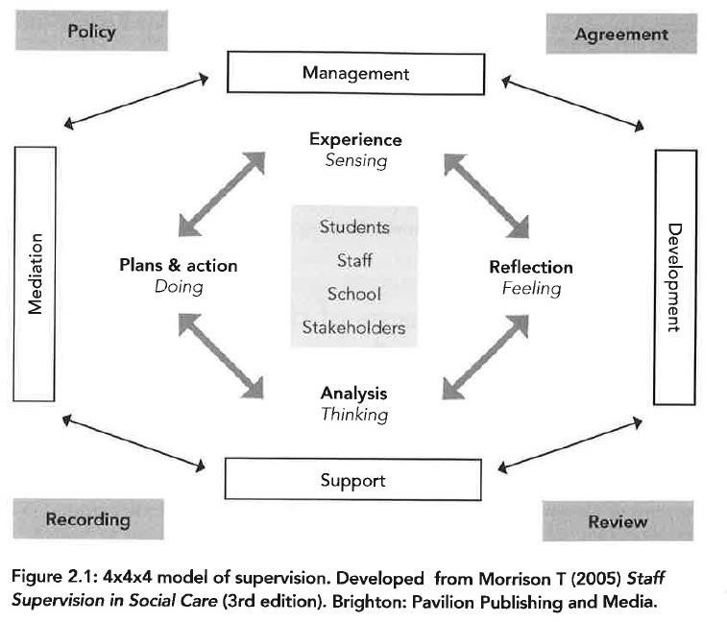

Statutory Guidance

Working Together to Safeguard Children states “effective practitioner supervision can play a critical role in ensuring a clear focus on a child’s welfare. Supervision should support practitioners to reflect critically on the impact of their decisions on the child and their family.”

The Statutory framework for the early years foundation stage states “providers must put appropriate arrangements in place for the supervision of staff who have contact with children and families. Effective supervision provides support, coaching and training for the practitioner and promotes the interests of children. Supervision should foster a culture of mutual support, teamwork, and continuous improvement, which encourages the confidential discussion of sensitive issues.”

Keeping children safe in education 2022 states “The role of the designated safeguarding lead carries a significant level of responsibility, and they should be given the additional time, funding, training, resources and support they need to carry out the role effectively.”

Purpose of Safeguarding Supervision for DSLs

The purpose of Safeguarding Supervision is to:

- provide protected time to reflect on practice
- provide support with emotional well-being, resilience, picking up on demands and developing coping strategies
- have an opportunity to off-load, talk about how they are feeling when dealing with distressed students and the impact on their own life. It should feel restorative and help build resilience
- review workloads and time management
- discuss and seek guidance on specific cases – review action plans, avoid drift. Provide a fresh eye, talk through intolerances, frustrations e.g., with other agencies/systems
- provide an opportunity where the DSL can be challenged supportively and constructively with advice offered on areas for improvement
- allow for issues relating to the workplace and to working practices to be identified and discussed including safer working practice and professional boundaries
- enable an opportunity for reflection, creative thinking and solution focussed thinking
- consider how their role fits with the rest of the school/other services and the community
- identify achievements and good practice
- consider appropriate CPD/training needs in relation to their safeguarding role

Principles

- Safeguarding supervision is not related to and does not replace appraisal but should complement it.
- It is not counselling and a supervisor at times may need to refer a supervisee to other services such as counselling.
- The relationship between supervisor and supervisee should be positive and trusting
- INSERT SCHOOL NAME Senior Leadership Team and Governors/Trustees should see supervision as an important aspect of the DSLs work and ensure adequate time is provided.
- Decision making on a child’s records should be signed off by the DSL who remains responsible.

Discussion

To reflect on individual cases/scenarios, the supervisor may find it useful to use

- Tell me
- Explain to me
- Describe to me

And consider 4 aspects

- SENSE – the story, what happened?
- FEEL – reflection, what was it like?
- THINK – Analysis, what does this mean?
- DO – Action plans, what next?

(Morrison T 2005) The Supervision Cycle

Supervision should enable the DSL to consider the best way to support the child or young person current needs, reflecting on and adapting responses to achieve the best outcome for the child or young person.

Safeguarding Supervision Contract (see page 5)

The supervisor should make a written contract/agreement with their DSL considering:

- Frequency and length of safeguarding supervision.
- Location – supervision should take place in a private and uninterrupted space during the working day.
- Recording – it is the supervisor’s responsibility to take notes and make sure they are made available to the Supervisee and filed. Both parties need to agree and sign that they are accurate. Records must be kept in a secure location. The records themselves must be kept in a format that suits both parties however a summary sheet of actions will be completed during or immediately after the session. A Recording Template is provided on Page 7. Case discussion with any changes in plan approved by the DSL are to go on a child’s safeguarding record.
- Confidentiality – in general, supervision is considered as confidential, however there will be occasions where confidentiality will be overridden, for example in the case of child protection issues relating to the Supervisee or if not sharing information with senior school management could contribute to bringing the school into disrepute, there is a potential disciplinary matter or whistleblowing issue.
- Preparation for supervision – supervisee should identify cases/issues to discuss and start to reflect on these.

Entitlement to Safeguarding Supervision

It is important that safeguarding supervision is provided to the DSL. If a DSL is not receiving safeguarding supervision at the required frequency during the year, they should:

- in the first instance discuss any complaints or dissatisfaction with their supervisor and endeavour to reach an agreement within the normal supervision process; or
- if a solution is not agreed, the supervisee should raise the issue with their Head Teacher/Principal.

Supervision Contract

To effectively support the supervision process, the following areas will be discussed during the meeting. It is the Supervisor’s and Supervisee’s responsibility to be prepared for the meeting in relation to each of these aspects:
- Be accountable for their practice and uphold the Schools professional standards and policies alongside the professional standards of Salford Local Authority and Salford Safeguarding Childrens Partnership policies and procedures.
- Build purposeful, professional relationships and communicate effectively.
- Make sound professional judgements based on good practice and seek advice from the line manager.
- Reflect on, analyse, and evaluate their practice and seek support to manage the emotional impact of their work e.g. in relation to child protection, SEND, staffing, CPD.
- Share, debrief and identify any further required resources to address stressful situations or those that cause them concern e.g. further training, issues with staffing structure, issues with specific children.
- Challenge constructively in the interests of children, families, staff, and other professionals who are in contact with the children in the care of INSERT SCHOOL NAME e.g. through following the Whistleblowing Policy/SSCP Effective Challenge and Escalation Procedure.
- Develop the knowledge, skills and values required for their own role, professional development, and as part of the wider school structure e.g. namely through the performance management cycle.
- Contribute to research and use knowledge and experience to explore new ways of working.
- Ensure peer and management review of professional decisions and to encourage mutual learning and development e.g. share experiences within the staff team through; staff meetings, feedback to teachers after lessons and challenging actions taken to safeguard children (as necessary and in keeping INSERT SCHOOL NAME Safeguarding and Child Protection Policy).
- Communicate with their line manager on issues that are identified in the school in relation to policies, procedures, organisational factors and children’s wellbeing and development.
- Adhering to the Whistleblowing Policy/Low Level Concerns Policy/Managing Allegations Against Staff GM procedures if concerns arise around a member of staff.
- Manage realistic workloads and discuss proactive ways of targeting this if levels increase.

Signatures
Supervisor: | Date:
Supervisee: | Date:

Designated Safeguarding Lead (DSL) – Safeguarding Supervision
A G E N D A
Date
Introduction | Welcome
 | Clarify roles and confidentiality
 | Agreed expectations
Specific case discussions (when appropriate also recorded on the child’s safeguarding file) | Review notes of previous meeting
 | Share Experience
 | Reflections (feelings)
Reflection | Analysis – celebrate success and good practice as well as consider. What could be improved?
 | Action Planning
Impact of work on individuals professionally or personally and any
additional support which may be necessary
 | Professional practice issues e.g. new policies, quality of performance, safer working practice, professional boundaries, role within school
Development | CPD support and access to resources e.g. reflect on recent or forthcoming training development opportunities
Completion | Any Other Business (AOB)
 | Date of Next Supervision

Safeguarding Supervision Notes and Action Template

Name of Supervisor: | Date of Supervision:
Name of Supervisee:

Where there is disagreement, but the supervisor feels it is necessary to record something they have been told, because of its possible impact, this should be discussed, and rationale also recorded. Both/All parties should receive a signed copy of the record following completion of the meeting.

What is going well?
Health/welfare, children & families, performance progress, professional development, additional responsibilities
Discussion/Reflection (including Actions from the last meeting)
Actions/Decisions (including timescales)

What has been a challenge?
Health/welfare, children & families, performance progress, professional development, additional responsibilities
Discussion/Reflection (including Actions from the last meeting)
Actions/Decisions (including timescales)

What do you think could be a future challenge?
Health/welfare, children & families, performance progress, professional development, additional responsibilities
Discussion/Reflection (including Actions from the last meeting)
Actions/Decisions
(including timescales)

Is there anything you would like support with?
Health/welfare, children & families, performance progress, professional development, additional responsibilities
Discussion/Reflection (including Actions from the last meeting)
Actions/Decisions
(including timescales)

Reflection on Performance Management Targets
Discussion/Reflection (including Actions from the last meeting)
Actions/Decisions (including timescales)

Any other business?
Discussion/Reflection (including Actions from the last meeting)
Actions/Decisions (including timescales)

Signatures
Supervisor: | Date:
Supervisee: | Date:

