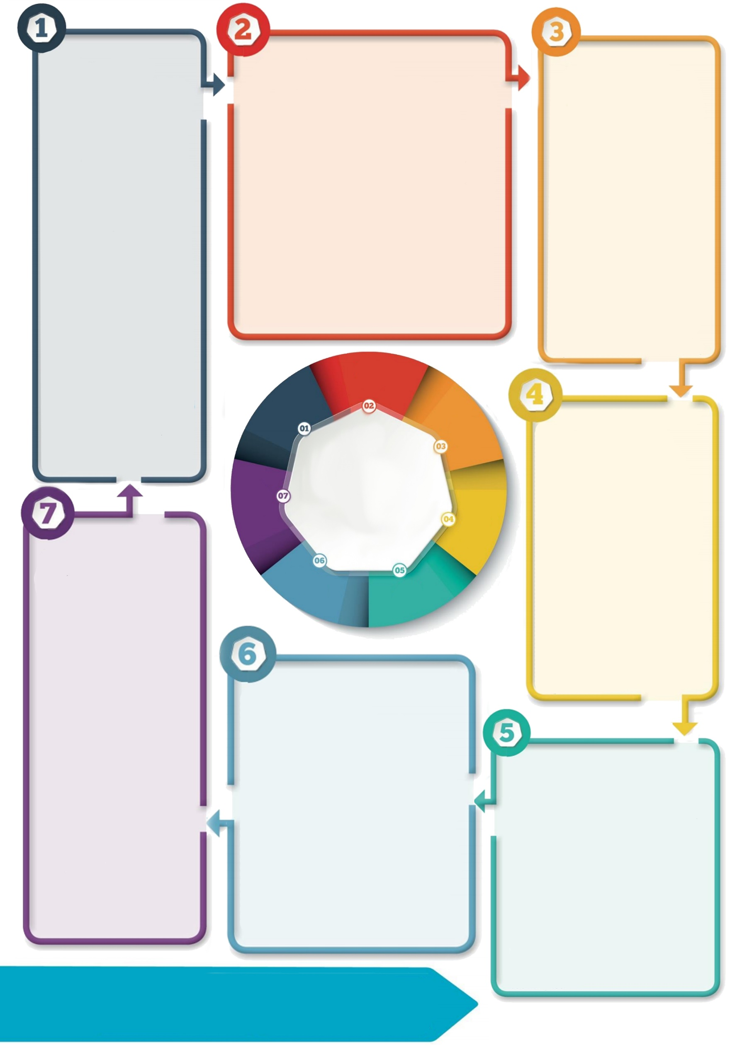

**Actions for all agencies**

1. Be familiar with the Salford [Obesity Pathway](https://safeguardingchildren.salford.gov.uk/media/1673/sscp-obesity-pathway-2021.pdf)
2. Use the websites that provide advice and support to families (see links in the pathway)
3. Learn to challenge
4. Know when to consider safeguarding when you see a child with obesity
5. Follow SSCP [Support and Safeguarding](https://safeguardingchildren.salford.gov.uk/professionals/support-and-safeguarding-formerly-the-thresholds-of-need-and-response/) (Thresholds) guidance

**Safeguarding & Obesity**

Consistent failure to change lifestyle and engage with agency support indicates neglect especially in younger children. Obesity is a part of wider concerns about neglect, and other forms of abuse. A comprehensive picture of child and family is needed to identify safeguarding issues. Be aware of issues relating to disguised non-compliance.

**Introduction**

Obesity is a growing concern with almost a third of 11 year olds in the UK being overweight or obese. Obesity depends on inherent and environmental factors (presence of an environment that facilitates development of obesity including lifestyle choices and availability of calorie rich energy dense foods and reduced activity levels). Child BMI is linked to maternal BMI, genetic factors and lower maternal education and is high in those in lowest deprivation deciles. Child abuse can be a key factor linked to obesity which is difficult to identify without multiagency information sharing. Understanding the impact of obesity on the child is key.

**Before safeguarding concerns are raised**

-Health teams: undertake assessments, provide advice & education to families on weight management, healthy living.

-Non-health teams: advise families to seek medical advice.

-Challenge families if actions advised are not carried out

-Share information based on GDPR principles.

-Request early help support **-** refer to the [Red Pepper programme](https://www.salford.gov.uk/health-and-social-care/health-services/health-improvement-connect/concerned-about-your-childs-weight/)**.**

-Provide [advice and support](https://www.salford.gov.uk/advice-and-support/welfare-rights-and-debt-advice-service/) to economically deprived families.

**Drivers for change**

A [Serious Case Review](https://safeguarding.network/content/wp-content/uploads/2019/09/2018ManchesterChildF1Overview.pdf) (Child F1) where a child died highlighted challenges in the system at various levels - from identification to discussion and tackling obesity within clinical settings; gaps in services; professional expertise in understanding causes of obesity; challenges faced in relation to diagnosis; discussion and getting appropriate multiagency information and uncertainties in consideration of the safeguarding threshold or actions to be taken.

**References**

[Recommendations from WHO’s Commission on Ending Childhood Obesity](https://www.eufic.org/en/healthy-living/article/recommendations-from-whos-commission-on-ending-childhood-obesity#:~:text=The%20Commission%20recognises%20that%20%E2%80%9Cchildhood,this%20generation%20and%20the%20next)

[Public Health Guidance on Obesity and the food environment](https://www.gov.uk/government/publications/health-matters-obesity-and-the-food-environment/health-matters-obesity-and-the-food-environment--2#:~:text=Obesity%20increases%20the%20risk%20of,risk%20factor%20for%20heart%20disease)

[Child F1 Serious Case Review](https://safeguarding.network/content/wp-content/uploads/2019/09/2018ManchesterChildF1Overview.pdf)

[Salford Obesity Pathway](https://safeguardingchildren.salford.gov.uk/media/1673/sscp-obesity-pathway-2021.pdf)

[SSCP Support and Safeguarding](https://safeguardingchildren.salford.gov.uk/professionals/support-and-safeguarding-formerly-the-thresholds-of-need-and-response/)

[SSCP Thriving Families Tool](https://safeguardingchildren.salford.gov.uk/professionals/neglect/)



**Additional Information**

**7MB Author: Dr Kalpesh Dixit, Designated Doctor Salford**

**Visit:** <https://safeguardingchildren.salford.gov.uk/>

**Email:** [SSCP@salford.gov.uk](mailto:SSCP@salford.gov.uk)

**Effects of obesity**

Obesity leads to physical health issues, mental health issues and affects life quality. Obese children become obese adults, increasing problems encountered in later life and impacting on health budget spending. Obese adults live an average of 10-15 years less.

It is important to identify safeguarding issues and provide challenges and multiagency support. Obesity is part of the [SSCP Neglect strategy](https://safeguardingchildren.salford.gov.uk/professionals/neglect/).

**Obesity & Safeguarding**

**7 Minute Briefing**

**Sub Title**